Table 1: List of Figures / Diagrams / Graphs
Figure No. | Title
Fig 1 | MERN Stack Architecture
Fig 2 | API Flowchart
Fig 3 | Project Workflow Diagram

Table 2: List of Tables
Table No. | Title
Table 1 | Training Schedule
Table 2 | Feature and Implementation
Table 3 | Performance Table

Table 3: List of Screenshots
Screenshot No. | Title
Screenshot 1 | MongoDB Data Schema
Screenshot 2 | Shopby Home Page
Screenshot 3 | Login Page
Screenshot 4 | Browse Products Page
Screenshot 5 | Cart Page
Screenshot 6 | About Page

Table 4: List of Abbreviations
Abbreviation | Full Form
MERN | MongoDB, Express.js, React.js, Node.js
API | Application Programming Interface
UI | User Interface
CRUD | Create, Read, Update, Delete
ODM | Object Data Modeling
VS Code | Visual Studio Code
CI/CD | Continuous Integration / Continuous Deployment
DB | Database
HTML | HyperText Markup Language

TABLE OF CONTENTS

S.No. | Contents | Page No
a | Abstract | i
b | List of Figures | ii
c | List of Tables | ii
d | List of Screenshots | ii
e | List of Symbols & Abbreviations | ii
1 | Introduction | 1
2 | Related work/ Technologies used | 2
3 | Work done/ Observation/ Duties performed | 4
4 | Learning after Internship | 10
5 | Summary / Conclusion | 13
6 | Bibliography | 14

1. INTRODUCTION
The internship at Cantilever Labs was a transformative experience that allowed me to immerse myself in the practical world of full-stack web development using the MERN Stack—MongoDB, Express.js, React.js, and Node.js. As a student of Computer Science and Engineering, this opportunity effectively bridged the gap between academic learning and industry-level implementation. It enabled me to directly engage with the core technologies that power modern web applications.
The primary objective of this internship was to gain comprehensive, hands-on exposure to the full software development lifecycle, including backend API design, frontend development, and the deployment of scalable, responsive web solutions. Under the guidance of experienced mentors, I developed a solid understanding of full-stack application architecture and workflows. I also learned to build secure, efficient, and modular web applications while collaborating within an agile, team-based environment.
Throughout the six-week duration of the internship, I actively contributed to real-time projects. My tasks included designing schemas in MongoDB, creating RESTful APIs with Express.js, developing interactive UI components using React.js, and deploying applications via platforms like Vercel and MongoDB Atlas. These experiences significantly enhanced my technical proficiency and deepened my knowledge of version control systems like GitHub, asynchronous programming, and debugging strategies.
This internship represented a major milestone in my path toward becoming a professional developer. It reinforced the value of clean and maintainable code, emphasized the importance of modular design principles, and highlighted the need for user-centric development approaches. Above all, it boosted my confidence to contribute meaningfully to real-world software projects and adapt to the ever-evolving demands of the technology industry.

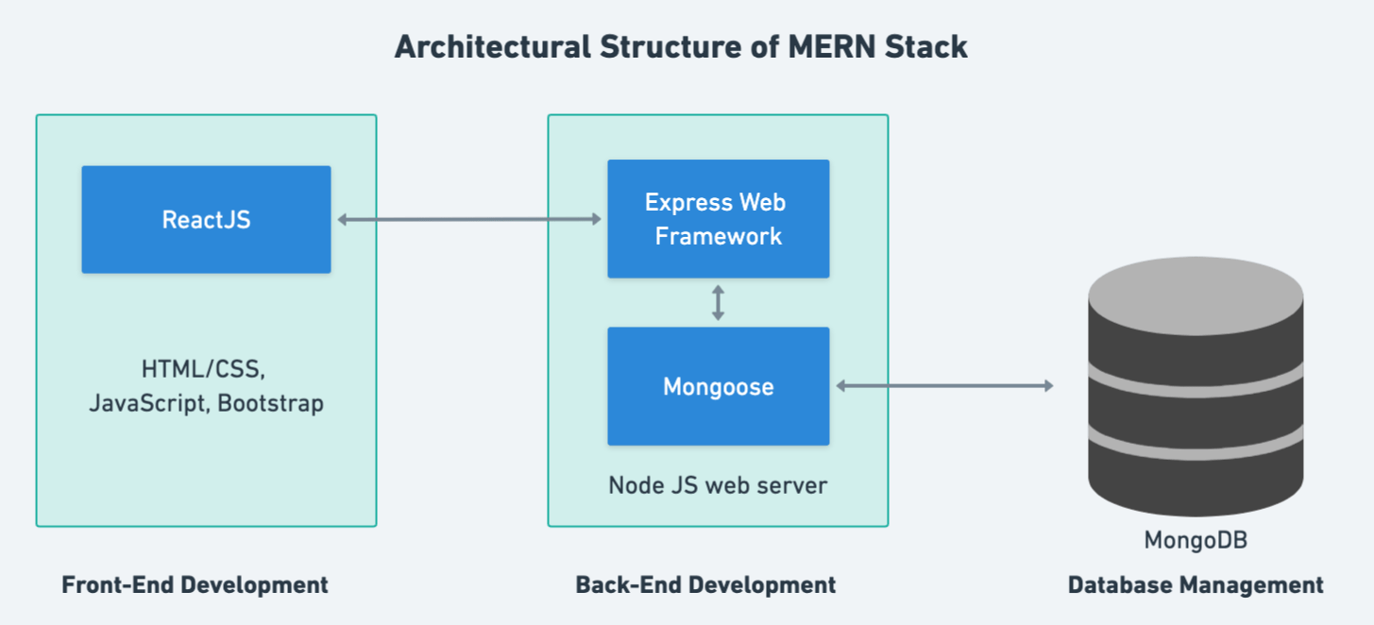

Figure 1. MERN Stack Architecture

2. RELATED WORK & TECHNOLOGIES USED
During my internship at Cantilever Labs, I gained hands-on experience with the MERN Stack, a robust and widely adopted full-stack web development framework comprising MongoDB, Express.js, React.js, and Node.js.
- MongoDB: A flexible, NoSQL database used to store and retrieve JSON-like documents. I utilized it to manage dynamic data, such as user credentials and product records. Working with Mongoose, an Object Data Modeling (ODM) library, I learned to design schemas and implement validation rules.
- Express.js: A minimalist and efficient backend framework used to handle HTTP requests and define server-side logic. I developed RESTful APIs for key functionalities such as user authentication, data management, and CRUD operations. Middleware components were integrated for routing, logging, and access control.
- React.js: A powerful frontend library used to build responsive, component-driven user interfaces. I developed UI elements like login pages, dashboards, and navigation menus using React Hooks such as useState and useEffect for effective state and lifecycle management.
- Node.js: A runtime environment that enabled server-side JavaScript execution. It formed the core of the backend, seamlessly integrating with Express.js to manage API requests and ensure smooth client-server communication.
Beyond the MERN stack, I also worked with several supporting tools that facilitated efficient development and deployment:
- Git & GitHub: Version control systems that streamlined code collaboration and maintenance. I learned to manage repositories, work with branches, resolve merge conflicts, and follow clean commit practices.
- Postman: An essential tool for testing and validating API endpoints. It was instrumental in ensuring reliable backend responses before integrating with the frontend.
- Vercel: A cloud-based deployment platform that made it easy to host frontend applications. I deployed projects using Vercel and connected them to MongoDB Atlas, a cloud-hosted database, gaining valuable experience in configuring production environments.
These technologies collectively enabled the creation of responsive, secure, and scalable full-stack applications. The stack offered a clear, layered workflow—allowing me to trace the complete journey of data, from user input on the frontend, through backend processing, to final storage and retrieval in the database. Each technology played a crucial role in delivering a seamless development experience and helped me build a deeper understanding of modern web architecture.

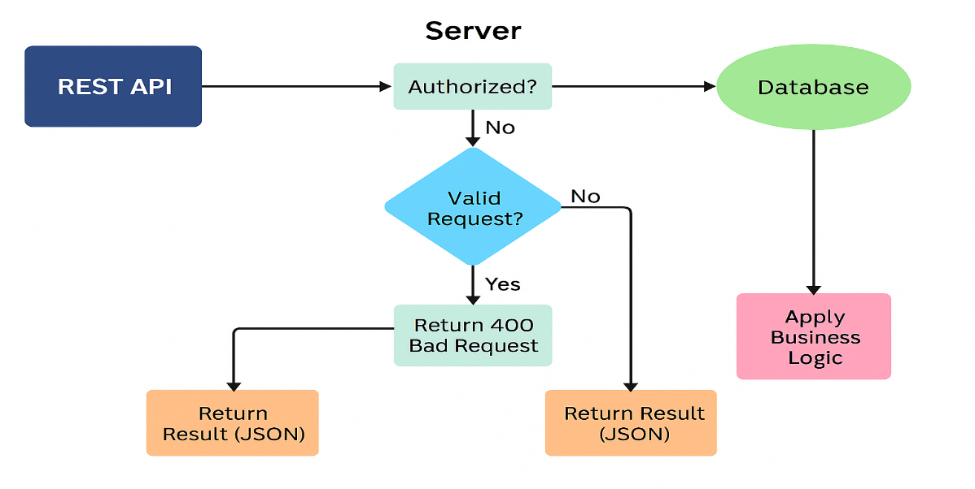
Figure 2. API Flowchart

3. WORK DONE & OBSERVATIONS

Throughout the six-week internship at Cantilever Labs, I actively participated in various real-world web development activities centered around the MERN Stack. The work involved backend programming, frontend UI development, database operations, and deployment—providing a comprehensive understanding of full-stack application development. Below is an overview of my key contributions and observations:

--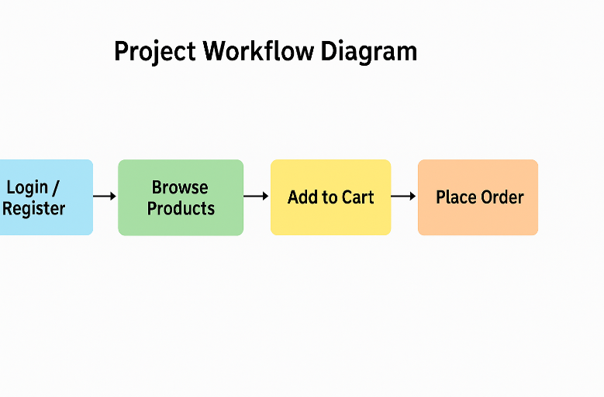
Figure 3. Project Workflow Diagram

Backend Development with Node.js & Express.js

The backend of this project was developed using Node.js as the runtime environment and Express.js as the web application framework. This stack was chosen for its lightweight, non-blocking I/O model, and its seamless integration with MongoDB via Mongoose.

The backend consists of several RESTful API endpoints responsible for core operations such as:

User Authentication: Routes to register and log in users using email and password.

Product Management: APIs to retrieve the list of available products from MongoDB.

Cart & Order Processing: Accepts user cart data and stores order details in the database.

Middleware such as cors and express.json() was used to handle cross-origin requests and parse incoming JSON payloads. Routes are modularized for better maintainability and scalability — with separate files handling /users, /products, and /orders.

MongoDB Atlas was integrated using the mongoose ODM to define schemas for products, users, and orders, enabling structured and schema-driven interaction with the database.

Overall, the backend ensures secure, scalable, and efficient data handling, acting as the backbone of the application's business logic and data persistence.

Frontend Development with React.js

The frontend of the project was developed using React.js, a popular JavaScript library for building fast, modular, and interactive user interfaces. The use of React enabled the creation of reusable components and a seamless, dynamic single-page application (SPA) experience.

Key features implemented in the frontend include:

Component-Based Architecture: The UI is broken down into modular components such as Header, Home, Product, Cart, Login, Order, and Footer, each responsible for specific functionality and layout.

Routing with React Router: Navigation between views is handled using react-router-dom, enabling clean URL paths like /products, /cart, /orders, etc., without full-page reloads.

State Management with Context API: A global context (AppContext) is used to manage shared state across components — including the user's login session, shopping cart contents, and available product list.

Axios for API Integration: The frontend communicates with the backend APIs using Axios for actions such as login, fetching products, placing orders, and viewing past orders.

Responsive UI: The user interface is styled with custom CSS to ensure a responsive layout across desktops and mobile devices. Basic animations and media queries improve the user experience.

Error Handling & Feedback: User feedback mechanisms such as loading indicators, alerts, and conditional rendering are implemented to handle login failures, empty carts, and order confirmations gracefully.

Overall, the React frontend provides a smooth and interactive interface for users to browse products, manage their cart, and place orders efficiently.

Database Integration

• Designed MongoDB schemas to structure and store data related to users and products.
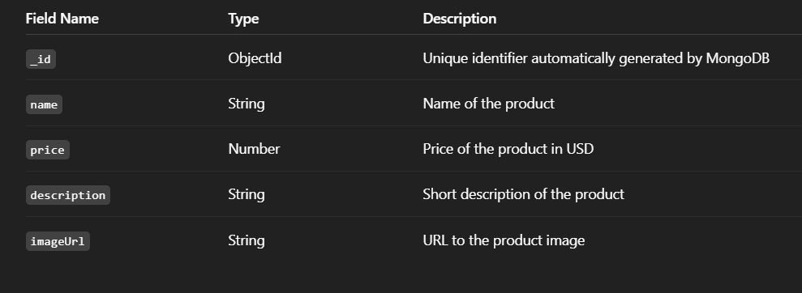
Screenshot 1. MongoDB Data Schema
• Leveraged MongoDB Atlas for cloud-based data storage and easy remote access.
• Performed CRUD operations and managed nested documents within collections.

Deployment

• Deployed the frontend application using Vercel, with automated updates via GitHub integration.
• Configured environment variables and secure keys for production-level deployment.
• Conducted API testing and validation using Postman prior to frontend-backend integration.

Screenshot 2: Shopby Home Page

`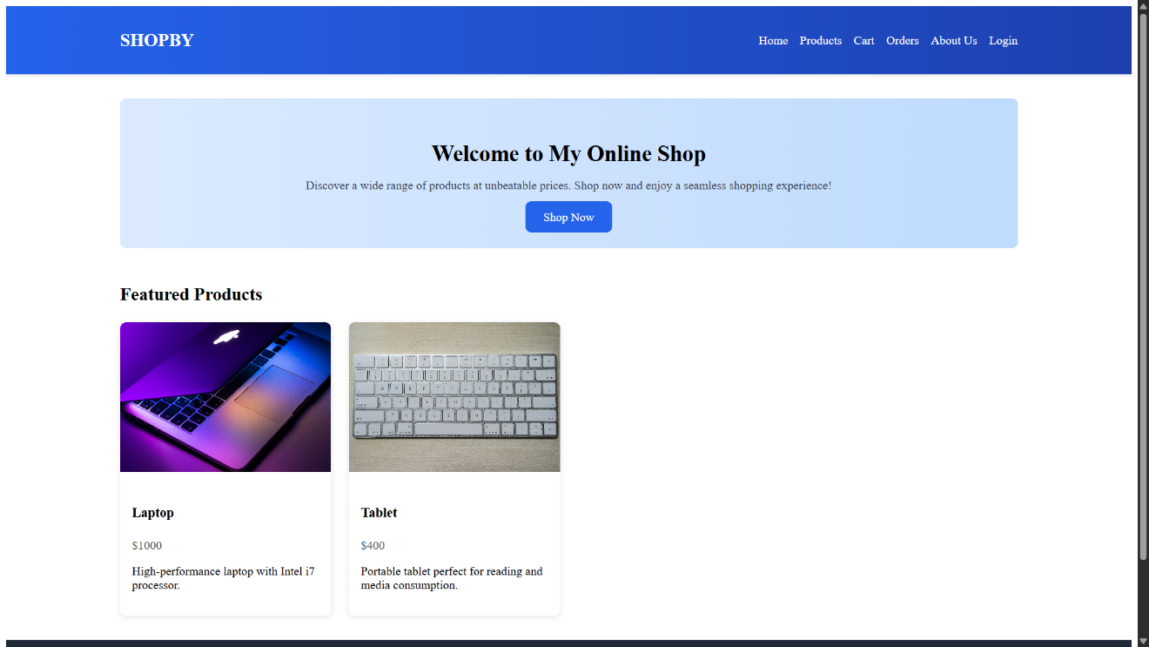
Screenshot 3:Login Page

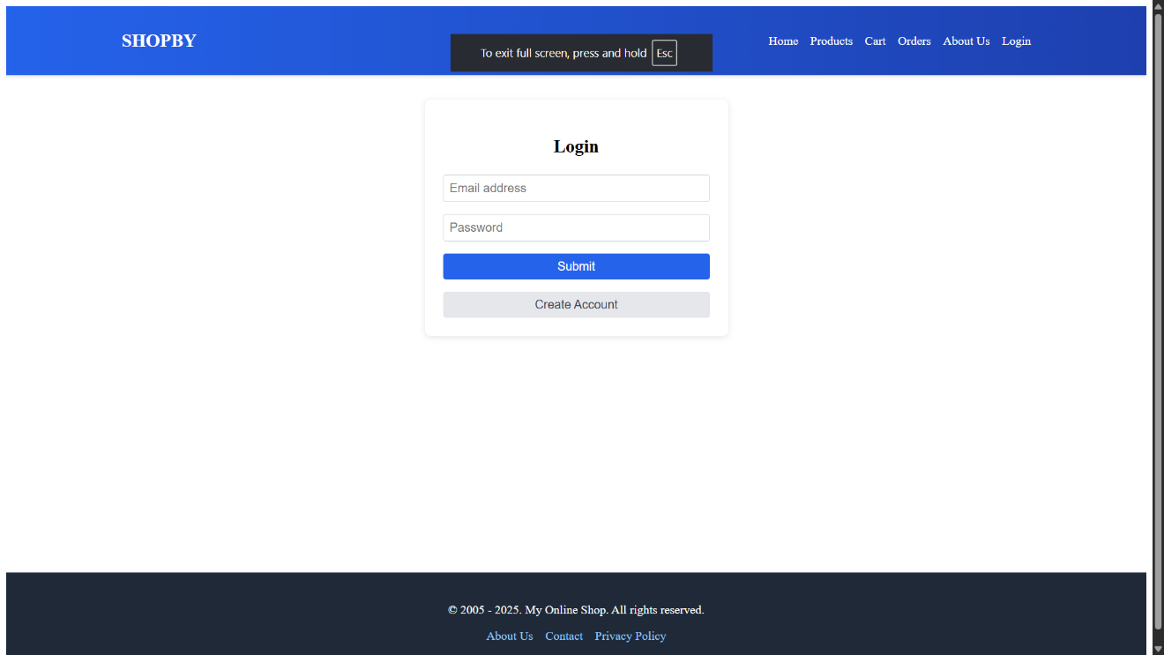

`
Screenshot 4: Browse Products Page

Screenshot 5: Cart Page

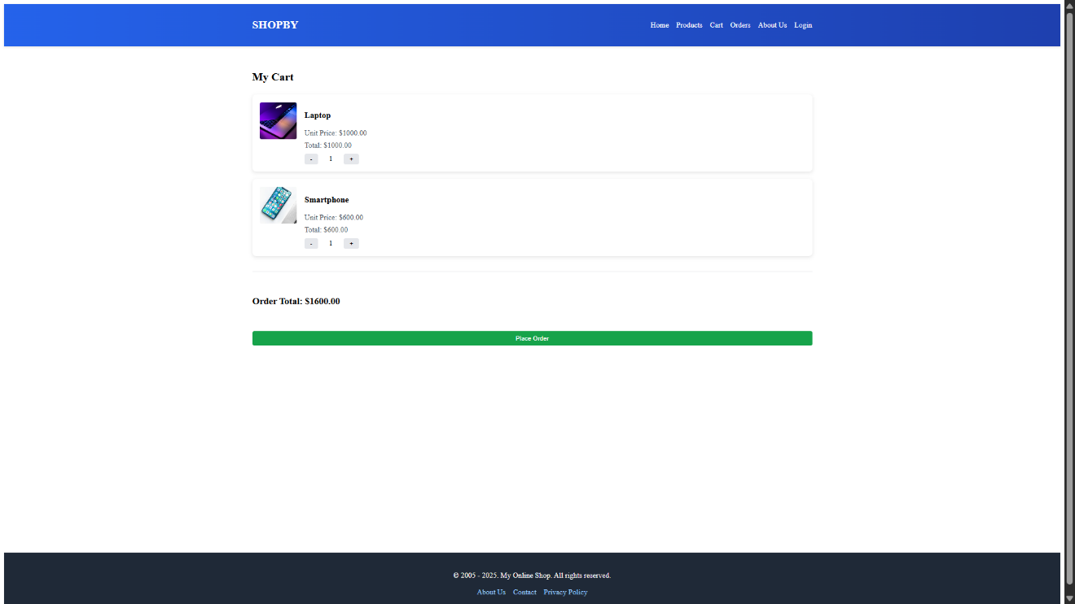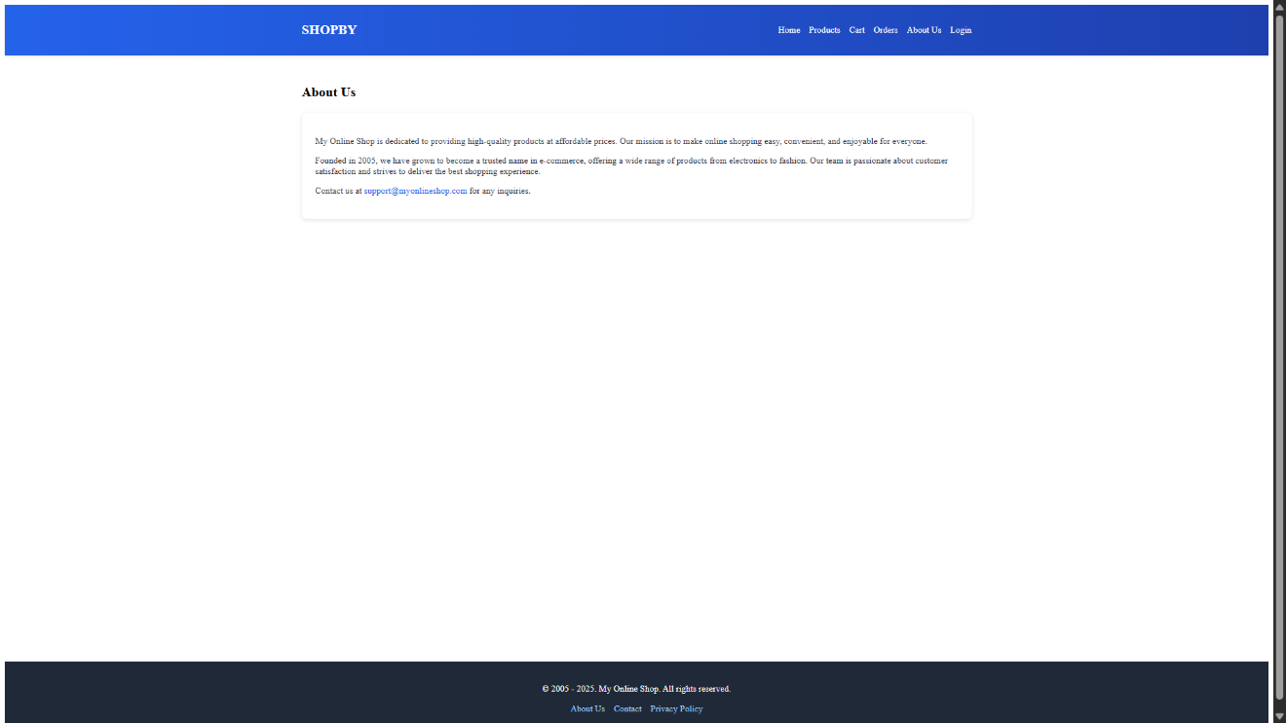
Screenshot 6: About Page

Version Control & Collaboration

Version control for the project was managed using Git, with the codebase hosted on GitHub. This allowed for efficient source code tracking, history management, and collaborative development.

Key practices adopted during development:

Repository Initialization: The backend and frontend were maintained as separate folders within a single Git repository to isolate concerns and improve modularity.

Regular Commits: Features and fixes were committed frequently with clear, descriptive messages to maintain a clean and understandable commit history.

Branching Strategy: Feature branches were used to develop and test new modules (e.g., login system, cart logic) before merging them into the main branch, ensuring stability of the main codebase.

Backup & Deployment Integration: The GitHub repository served not only as a version control platform but also as a deployment source for platforms like Vercel (for the React frontend) and Render (for the Express backend).

Collaboration: The version control system enabled multiple contributors to work concurrently, track code changes, and resolve conflicts efficiently using pull requests and code reviews.

3.1 Challenges Faced
During my internship at Cantilever Labs, I encountered a variety of technical and collaborative challenges that significantly contributed to my growth as a full-stack developer. These experiences enhanced my problem-solving skills and deepened my practical understanding of web development.
• Deployment Complexities: Deploying the final application using Vercel and MongoDB Atlas involved challenges related to configuring environment variables and aligning API routes. Troubleshooting deployment errors and refining build settings required several iterations and careful analysis of deployment logs.
• Authentication Integration: Implementing JWT-based authentication and securing application routes posed initial difficulties. Synchronizing frontend token storage with backend verification, as well as handling scenarios like token expiration and unauthorized access, required focused effort and testing.
• Asynchronous Data Handling in React: Managing asynchronous API calls in React using Axios was initially challenging. Issues such as race conditions, loading delays, and improper error boundaries prompted revisions in my component structure and a deeper understanding of React Hooks for state and side-effect management.
• Version Control and Team Collaboration: Working with Git and GitHub in a team environment introduced challenges like resolving merge conflicts and maintaining a clean commit history. These situations helped me improve my proficiency in branch management, pull requests, and collaborative development workflows.
• Debugging and Troubleshooting: Some bugs, such as inconsistent API responses or unpredictable React state behaviour, were complex to identify. By leveraging tools like Postman, browser developer tools, and systematic console logging, I sharpened my debugging approach and gained confidence in resolving backend and frontend issues.
Each of these challenges turned into valuable learning opportunities. They not only solidified my understanding of the MERN stack but also equipped me with the resilience and resourcefulness needed to work on real-world software projects.
3.2 Impact and Contributions
As an intern at Cantilever Labs, I played an active role in the development team, contributing meaningfully to feature implementation, system optimization, and workflow enhancement. My efforts had a direct impact on the quality and functionality of the application. Key highlights of my contributions include:
• API Development and Integration: Participated in the design and implementation of RESTful APIs that supported core functionalities such as user registration, authentication, and product management. These APIs ensured smooth data flow and robust client-server communication.
• Frontend Enhancements: Developed reusable React components for the login interface, user dashboard, and profile view. These enhancements significantly improved user experience through responsive design and interactive elements.
• Security Implementation: Integrated JWT-based authentication mechanisms with route protection to safeguard sensitive operations. This strengthened the application's security and ensured controlled access to user-specific resources.
• Project Deployment: Assisted in deploying the web application using Vercel, and configured connections to MongoDB Atlas for seamless backend integration. This setup allowed real-time testing and stakeholder access in a live environment.
• Collaborative Development: Maintained clean and modular code, actively contributing to a shared GitHub repository. Participated in peer code reviews and resolved merge conflicts, thereby supporting efficient teamwork and maintaining project stability.
These contributions not only advanced the project’s objectives but also enhanced my own competencies in full-stack development and collaborative engineering practices.

Summary Table: Key Features and Implementation Details
Table-2. Features and Implementation
Feature | Implementation Details
User Authentication | Login and registration system built with React forms; authentication handled via Express routes
Product Listing | Product data stored in MongoDB; accessed via Express.js REST APIs
Cart Management
  Cart state managed globally using React Context API; persistent during session
Order Placement | Orders placed via POST requests (/orders/new) and stored in MongoDB using Mongoose
Backend Framework | Built using Node.js and Express.js with modular route structure
Deployement | Frontend deployed to Vercel; backend hosted on Render and connected to MongoDB Atlas
API Integration | Axios used on frontend to fetch and render dynamic backend data
Frontend Framework | Developed using React.js with reusable components and dynamic UI rendering

Observations
During the development and testing of the project, several important observations were made regarding both functionality and performance:
The use of React’s Context API significantly simplified state management across components such as the cart, products, and user authentication.
Express.js and Node.js provided a stable and lightweight backend that handled API requests efficiently. Mongoose enabled structured schema validation which reduced runtime errors.
Alerts and conditional rendering in the frontend greatly improved user experience by providing instant feedback (e.g., login failure, empty cart, successful order).
The interface adapted well across various screen sizes and browsers, maintaining usability even on mobile devices.
API response times were fast in the local environment; however, initial latency was observed when the backend (hosted on Render) restarted due to inactivity.
MongoDB Atlas reliably stored product and order data. No data loss or corruption occurred during testing, even with concurrent actions.
Although basic user authentication was implemented without encryption (e.g., JWT), it was functional for prototype/demo purposes.

4. LEARNING AFTER INTERNSHIP
This internship at Cantilever Labs offered more than just technical exposure—it served as a transformative journey that shaped my development as both an aspiring software engineer and an effective team contributor. The key takeaways from this experience are outlined below:
- Technical Proficiency
• Acquired practical experience in developing secure, scalable applications using the MERN stack.
• Gained a deep understanding of frontend-backend integration for smooth user experiences.
• Improved skills in debugging, asynchronous operations, and API testing.
• Gained hands-on familiarity with essential development tools like VS Code, Git, Postman, Vercel, and MongoDB Atlas.
- Development Methodologies
• Embraced clean coding practices and modular design principles for maintainable development.
• Practiced agile methodologies through sprint planning, task prioritization, and iterative development.
• Understood the role of version control systems and collaborative workflows in professional projects.
- Analytical and Problem-Solving Abilities
• Addressed practical issues such as broken UI states, backend errors, and integration challenges.
• Strengthened logical thinking and persistence through hands-on debugging and troubleshooting.
- Teamwork and Communication
• Enhanced communication skills through regular mentor discussions, team sync-ups, and code reviews.
• Learned the importance of seeking feedback, offering solutions, and maintaining clarity in collaboration.
- Preparedness for the Industry
• Gained the confidence to work on live projects aligned with production standards.
• Developed awareness of current technologies, tools, and best practices in full-stack development.
This internship provided a well-rounded experience, blending technical depth with collaborative practice. It allowed me to engage with real-world engineering challenges and offered a glimpse into the creativity, discipline, and teamwork that drive success in the software development industry.

4.1 Personal Reflections
This internship experience marked a significant milestone in my journey toward becoming a software engineer. Immersing myself in MERN stack development allowed me to experience the complete lifecycle of building a web application—from initial concept to live deployment—bringing theoretical knowledge to life through hands-on execution.
Working in a structured, professional environment deepened my understanding of essential development practices such as planning, teamwork, and writing clean, maintainable code. I came to appreciate that software development extends beyond coding—it is about designing systems that are scalable, reliable, and purpose-driven.
I found particular enjoyment in developing frontend interfaces using React, where I explored component-based architecture and responsive design. This sparked a strong interest in frontend engineering. At the same time, working on API development helped me understand the crucial role of backend systems in enabling dynamic, data-driven applications.
Beyond technical growth, this internship taught me the value of patience, adaptability, and learning under pressure. Overcoming challenges and witnessing the successful deployment of the final application significantly boosted my confidence.
In retrospect, this experience has had a lasting impact on my career goals. It has reaffirmed my interest in pursuing a career in full-stack development and inspired a deeper commitment to continuous learning and innovation in the field of web development.

4.2 Future Scope and Improvements
While this internship offered a strong foundation in MERN stack development, there are several areas that present opportunities for further growth and refinement in future projects:
- Implement secure user authentication using JWT tokens and password hashing for enhanced security.
- Introduce an admin panel for managing products, viewing orders, and monitoring user activity.
- Enable image uploads for products via cloud storage (e.g., Cloudinary or Firebase).
- Add order history tracking and detailed receipts for users.
- Implement pagination and search filters on the product listing page for better user experience.
- Integrate email notifications for order confirmation and user registration.
- Enhance the UI/UX with a design framework like Tailwind CSS or Material UI.
- Enable guest checkout or persistent cart storage for non-logged-in users.
- Improve deployment performance using serverless functions or continuous deployment pipelines.

5. CONCLUSION
My internship at Cantilever Labs has been a highly enriching and transformative experience that offered deep insight into the field of full-stack web development. Working with the MERN stack provided me with the opportunity to design and develop complete web applications, address real-world technical challenges, and build scalable solutions through practical implementation.
From creating MongoDB schemas and building RESTful APIs with Express and Node.js, to designing interactive interfaces using React and deploying applications via Vercel, every stage of the development lifecycle enhanced my understanding of modern web technologies. These experiences allowed me to move beyond theoretical learning and engage in the intricacies of client-server communication, secure data management, and agile collaboration.
Beyond technical expertise, the internship taught me to approach problems with a developer’s mindset—breaking down complex challenges, writing efficient and maintainable code, and continuously refining my skills. The guidance and mentorship of Mr. Praveen Nair played a crucial role in boosting my confidence and shaping my ability to contribute effectively to industry-level projects.
Overall, this internship marks a significant milestone in my academic and professional journey. It has solidified my passion for software development and equipped me with the skills, mindset, and motivation needed to pursue a successful career in the ever-evolving tech industry.

6. BIBLIOGRAPHY
The concepts, technical implementation, and insights presented in this report are entirely derived from experiential learning and mentorship received during the internship at Cantilever Labs. The primary sources of information include the technical guidance and continuous support from Mr. Praveen Nair, my internship mentor (https://www.linkedin.com/in/nairprv/) ; hands-on training sessions and project-based learning conducted throughout the internship program; and real-time collaboration, code reviews, and peer discussions within the development environment. No external books, tutorials, websites, or published references were used in the preparation of this report. All documented content is a direct outcome of the practical exposure and tasks executed under the supervision of Cantilever Labs.

